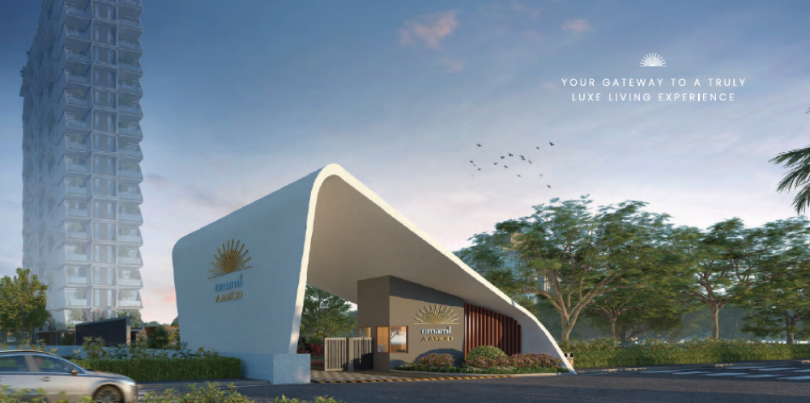

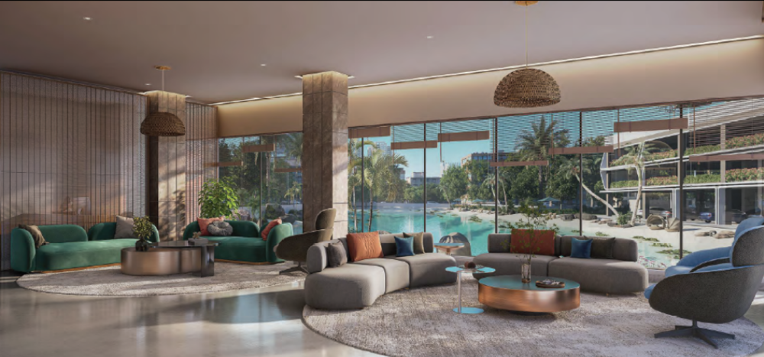
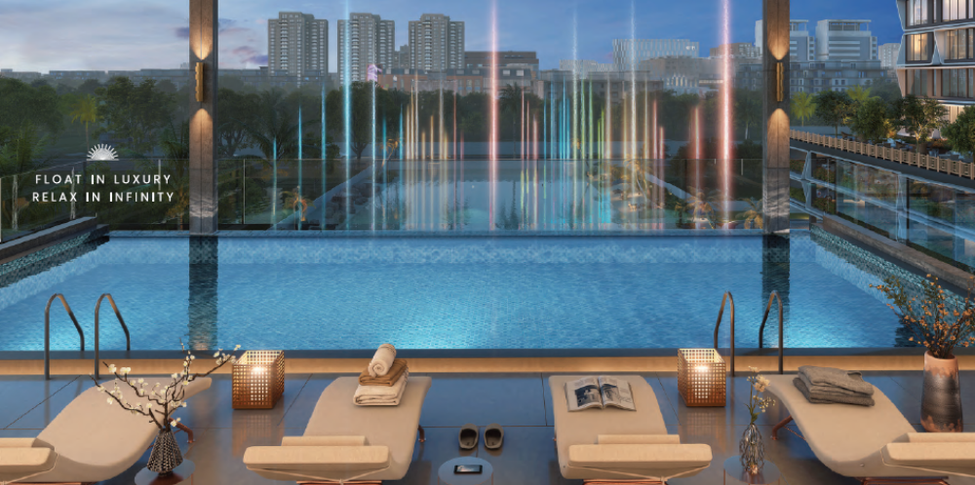

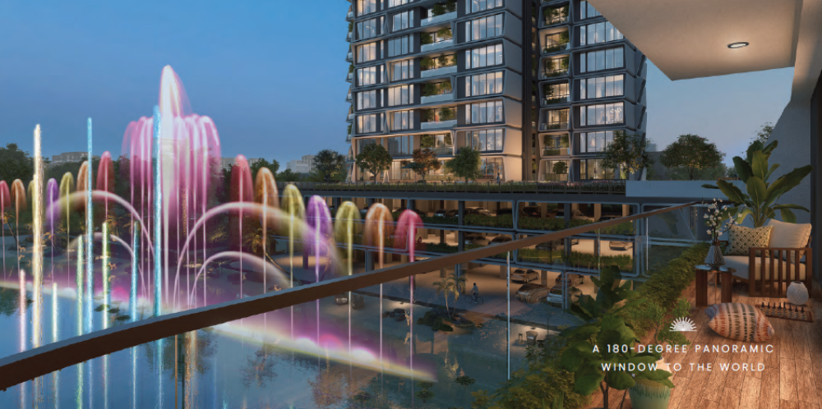

Amenities
Amusement & Premium Facilities:
- Musical Fountain Lake
- 180 Degree panoramic view infinity edge pool
- Amphitheatre
Lifestyle:
- Premium Club House
- Bar Lounge Facing Lake
- Banquet Hall
- Steam / Spa
- Lavish Club Lobby Sit-Out
Green Zones and Decks:
- Kids Play Area
- Sculpture Garden
- Deck with Tensile Canopy
- Topiary Garden
- Pet Relief Area
- Event Garden
- Lawn
- Reflexology
- Parterre Garden
- Fragrance Garden
- Deck with Trellis
- Senior Citizen Park
- Sunken Sit Out
- Wooden Deck
- Palm Court
- Sit Out Plaza
Sacred Temple
Security:
- 10- Tier Security
- Entry Gate with Guard Rooms
Sky High Vibes Terrace:
- Skating Rink at Terrace
- Stargazing Deck
- Yoga deck
- Sitting Area with lake view
- Barbeque with Wooden Deck
Sports & Fitness Activities:
- Pickleball court
- Squash court
- Gymnasium
- Aerobics / Pilates Ring
- Cricket Net
- Kid’s Play Area
- Basket Ball court
- Walkway
Multipurpose Sports:
- Chess, Carrom etc
- Table Tennis
- Snooker
